Chapter 12, Solution 68.

- 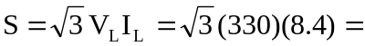

- 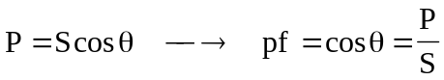

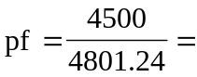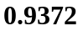

- For a wye-connected load,


 